# Assignment – 3

Python Programming

|  |  |
| --- | --- |
| Date | 03 October 2022 |
| Name | PRADEEP KUMAR B |
| Team ID | PNT2022TMID04713 |
| Project Name | IoT Based Smart Crop Protection System for Agriculture |
| Maximum Marks | 2 Marks |

# Question 1:

Write a python code for Blinking LED and Traffic Lights for Raspberry pi.

Solution:

import turtle

import time

wn= turtle.getscreen()

wn.bgcolor("grey")

#gui interfrace

pen= turtle.Turtle()

pen.color("orange")

pen.width(6)

pen.hideturtle()

pen.penup()

pen.goto(-30, 60)

pen.pendown()

pen.fd(60)

pen.rt(90)

pen.fd(120)

pen.rt(90)

pen.fd(60)

pen.rt(90)

pen.fd(120)

#red light

red_light =turtle.Turtle()

red_light.shape("circle")

red_light.color("black")

red_light.penup()

red_light.goto(0, 40)

#Yellow light

yellow_light =turtle.Turtle()

yellow_light.shape("circle")

yellow_light.color("black")

yellow_light.penup()

yellow_light.goto(0, 0)

#Green light

green_light =turtle.Turtle()

green_light.shape("circle")

green_light.color("black")

green_light.penup()

green_light.goto(0, -40)

while True:

green_light.color("black")

red_light.color("red")

print("Red light Blinked ")

print("Blink!!")

time.sleep(3)

print("Blink!!")

red_light.color("black")

yellow_light.color("yellow")

green_light.color("black")

print("Yellow light Blinked")

print("Blink!!")

time.sleep(3)

print("Blink!!")

red_light.color("black")

yellow_light.color("black")

green_light.color("green")

print("Green light on")

print("Blink!!")

time.sleep(2)

print("Blink!!")

wn.mainloop()

**OUTPUT :**

**Red Light :**

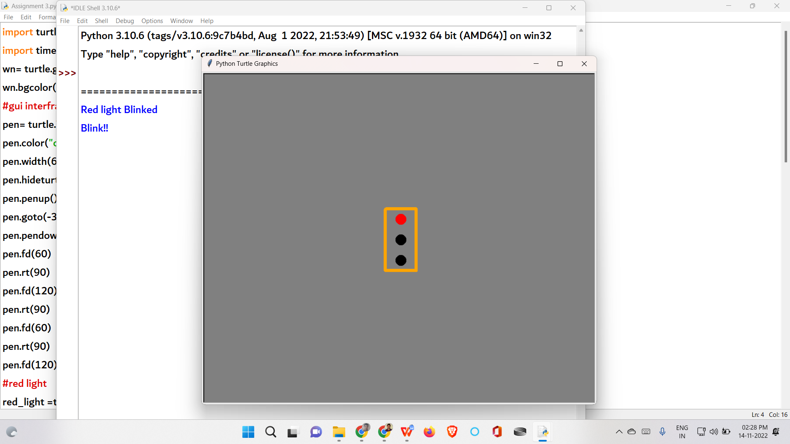

**Yellow Light :**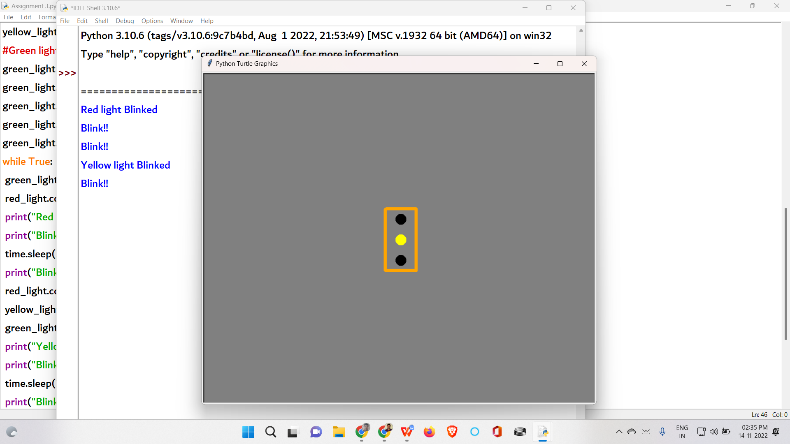

**Green Light :**

